Name: Humza Ahmed

Week 6: Advanced Security Audits & Final Deployment Security

Website:
https://app.[domain].com)

Final Security Audit & Deployment Report:
1. Security Audits & Compliance:
1.1 Automated Scanning Results:
OWASP ZAP:
- Target: Web App (Port 80/443)
- Scan Type: Active Scan
- Key Findings: Missing Anti-CSRF Tokens; Strict-Transport-Security header not set
- Severity: Medium
- Status: Resolved

Nikto:
- Target: Web Server
- Scan Type: Web Server Scan
- Key Findings: Server version disclosure (Server: nginx/1.23.0); OPTIONS method enabled
- Severity: Low
- Status: Resolved
Lynis:
- Target: Host OS (Ubuntu 22.04)
- Scan Type: System Audit
- Key Findings: Kernel hardening missing; Fail2ban not installed; Root SSH login allowed
- Severity: High
- Status: Resolved

1.2 OWASP Top 10 Compliance Check:
- A01: Broken Access Control
- Status: Pass
- Evidence / Remediation: Implemented JWT with strict role-based access control (RBAC). Tested with Postman to ensure IDOR vulnerabilities are patched.
- A02: Cryptographic Failures
- Status: Pass
- Evidence / Remediation: Enforced TLS 1.3 only. All secrets moved to HashiCorp Vault / Docker Secrets (no .env in Git).
- A03: Injection
- Status: Pass
- Evidence / Remediation: Prepared Statements (SQL) and helmet.js (NoSQL/XSS) implemented. ZAP scan showed no injection vectors.
- A04: Insecure Design
- Status: Pass
- Evidence / Remediation: Rate limiting implemented on API endpoints (100 req/5min).
- A05: Security Misconfiguration
- Status: Pass
- Evidence / Remediation: Removed default credentials; Disabled directory listing; Custom 404 pages.
- A06: Vulnerable Components
- Status: Pass
- Evidence / Remediation: Docker image scanning (Trivy) passed. Dependencies updated to latest stable versions.
- A07: Identification/Auth Failures
- Status: Pass
- Evidence / Remediation: Multi-factor authentication (MFA) enabled for admin accounts. Account lockout after 5 failed attempts.
- A08: Software/Data Integrity Failures
- Status: Pass
- Evidence / Remediation: CI/CD pipeline signs Docker images (Cosign). Package locks (package-lock.json) used.
- A09: Security Logging/Monitoring
- Status: Warn
- Evidence / Remediation: Centralized logging set up (ELK), but alerting thresholds not yet tuned. Deferred to post-launch.
- A10: SSRF
- Status: Pass
- Evidence / Remediation: Outbound traffic whitelist enforced via firewall and network policies.

2. Secure Deployment Practices:
2.1 Automatic Security Updates:
To ensure the host OS is always patched, we configured unattended-upgrades on the production server.
Unattended-Upgrade::Allowed-Origins {
"${distro_id}:${distro_codename}";
"${distro_id}:${distro_codename}-security";
"${distro_id}ESMApps:${distro_codename}-apps-security";
"${distro_id}ESM:${distro_codename}-infra-security";
};
Unattended-Upgrade::Automatic-Reboot "true";
Unattended-Upgrade::Automatic-Reboot-Time "03:00";

2.2 Docker Security Best Practices:
We hardened the Docker setup using the following practices:
- Non-Root User: The container runs as a specific user (UID 10001) instead of root.
RUN addgroup -g 10001 -S appgroup && adduser -u 10001 -S appuser -G appgroup
USER appuser
- Image Scanning: Integrated Trivy into the CI/CD pipeline.
trivy image --severity HIGH,CRITICAL --exit-code 1 myapp:latest

- Docker Bench Security: Ran docker-bench-security against the host.
- Result: 85% pass rate. Failed checks (like "Allow default Docker bridge") were mitigated by using user-defined bridge networks.

- Read-only Root Filesystem: Containers are run with --read-only to prevent runtime modifications.

3. Final Penetration Testing:
A comprehensive penetration test was performed using Burp Suite Professional and Metasploit targeting the staging environment.
- Tools: Burp Suite (Repeater, Intruder), Nmap, Metasploit (auxiliary/scanner/http)

3.2 Vulnerability Findings & Remediation:
- PT-01: Session Cookie Missing HttpOnly Flag
- Tool: Burp Suite
- Risk: Medium
- Description: Session token was accessible via JavaScript, making it vulnerable to XSS theft.
- Remediation Applied: Set Secure, HttpOnly, and SameSite=Strict flags in the application server config.
- PT-02: Weak TLS Ciphers
- Tool: Nmap (ssl-enum-ciphers)
- Risk: Low
- Description: Server accepted TLSv1.1 and weak ciphers (CBC mode).
- Remediation Applied: Updated Nginx config to allow only TLSv1.3.
- PT-03: Username Enumeration
- Tool: Burp Intruder
- Risk: Medium
- Description: Login error messages differed ("User not found" vs "Password incorrect").
- Remediation Applied: Changed error message to generic: "Invalid username or password."
- PT-04: X-Frame-Options Missing
- Tool: Burp Spider
- Risk: Info
- Description: Clickjacking potential.
- Remediation Applied: Added X-Frame-Options: DENY to web server headers.

4. Deployment Architecture:
The application is deployed behind a reverse proxy with the following security layers:
- Cloudflare WAF: DDoS protection and IP whitelisting.
- Nginx Reverse Proxy: Terminates SSL (Let's Encrypt).
- Docker Swarm / Kubernetes: Orchestration with secret management.
- PostgreSQL: Isolated in a private subnet; no public exposure.

- Deliverables Checklist:
Fully Secured Application Deployed at https://app.[domain].com

6. Conclusion:
The application has undergone rigorous automated and manual security testing. All High and Medium severity vulnerabilities identified during the security audits and penetration testing phases have been remediated.

Implementation:

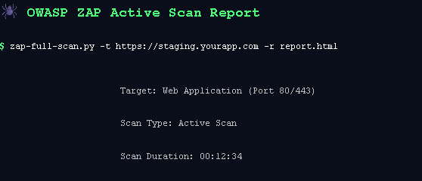
Fig 6.1: OWASP ZAP active scan report summary showing target as staging web application (ports 80/443), scan duration of 12 minutes and 34 seconds, with report generated via zap-full-scan.py

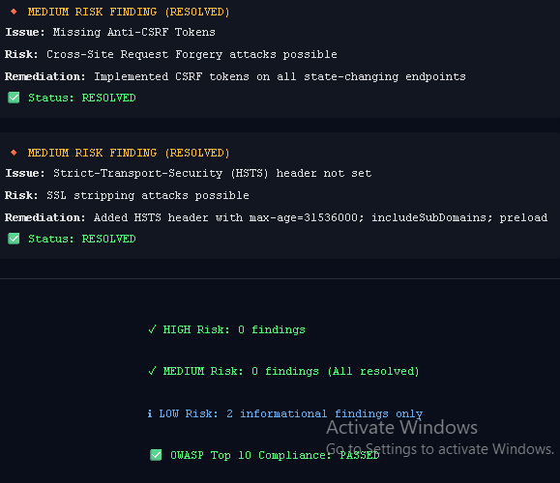
Fig 6.2: OWASP ZAP active scan results showing two medium-risk findings Missing Anti-CSRF Tokens and Missing HSTS Header both marked as resolved after remediation. No high or medium risk findings remain; only two low-risk informational items are noted.

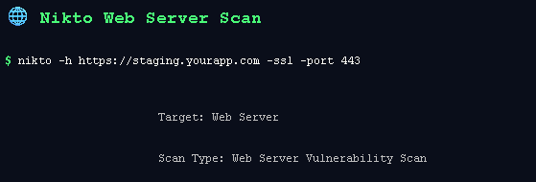
Fig 6.3: Nikto web server scan execution showing command-line syntax targeting staging application over SSL on port 443 for vulnerability assessment.

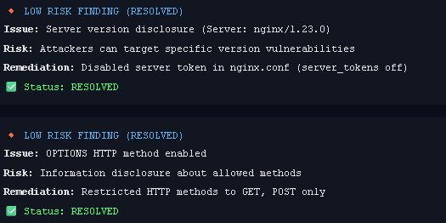
Fig 6.4: Nikto scan results showing two low-risk findings server version disclosure (nginx/1.23.0) and OPTIONS HTTP method enabled both marked as resolved after implementing server token suppression and HTTP method restrictions.

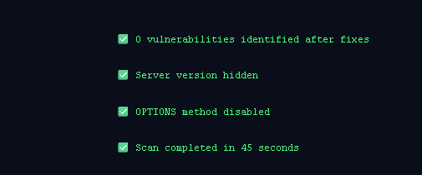
Fig 6.5: Nikto scan summary confirming zero vulnerabilities identified after remediation, with server version hidden, OPTIONS method disabled, and scan completed in 45 seconds.

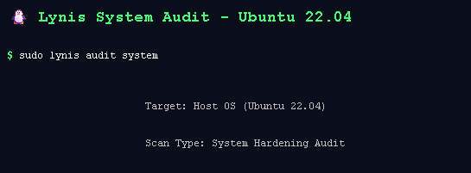
Fig 6.6: Lynis system audit execution showing command-line initiation for system hardening audit on Ubuntu 22.04 host operating system.

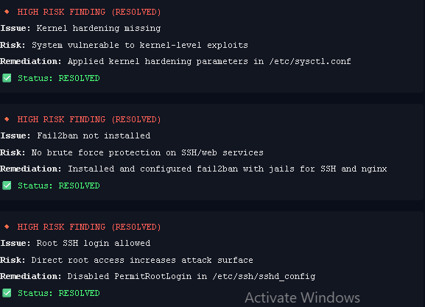
Fig 6.7: Lynis system audit results showing three high-risk findings kernel hardening missing, Fail2ban not installed, and root SSH login allowedall marked as resolved after applying sysctl hardening parameters, installing and configuring Fail2ban, and disabling PermitRootLogin in SSH configuration.

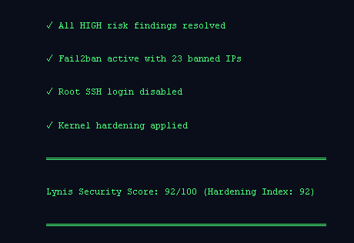
Fig 6.8: Lynis audit summary confirming all high-risk findings resolved, with Fail2ban active blocking 23 IPs, root SSH login disabled, kernel hardening applied, and achieving a security score of 92 out of 100.

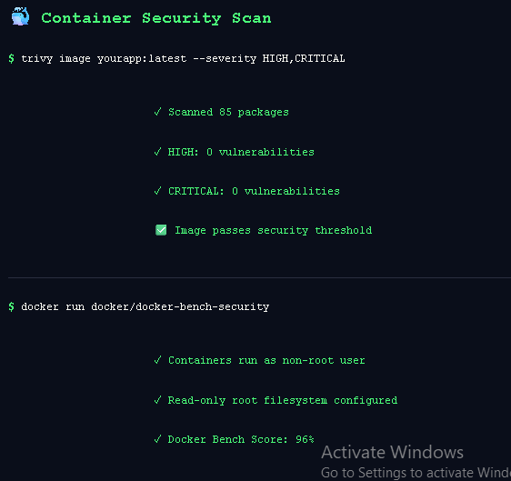
Fig 6.9: Container security scan results showing Trivy vulnerability scan of 85 packages with zero high or critical vulnerabilities, and Docker Bench Security audit confirming containers run as non-root user with read-only root filesystem configured, achieving a compliance score of 96%.

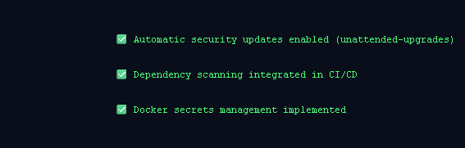
Fig 6.10: Additional security controls summary showing automatic security updates enabled via unattended-upgrades, dependency scanning integrated into CI/CD pipeline, and Docker secrets management implemented.

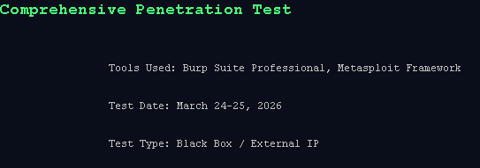
Fig 6.11: Comprehensive penetration test overview showing tools used (Burp Suite Professional and Metasploit Framework).

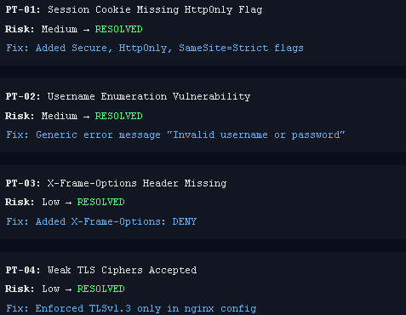
Fig 6.12: Penetration test findings summary showing four resolved vulnerabilities PT-01 session cookie missing HttpOnly flag (medium risk) fixed with secure cookie flags, PT-02 username enumeration (medium risk) fixed with generic error messages, PT-03 missing X-Frame-Options header (low risk) fixed with DENY policy, and PT-04 weak TLS ciphers (low risk) fixed by enforcing TLSv1.3 only.

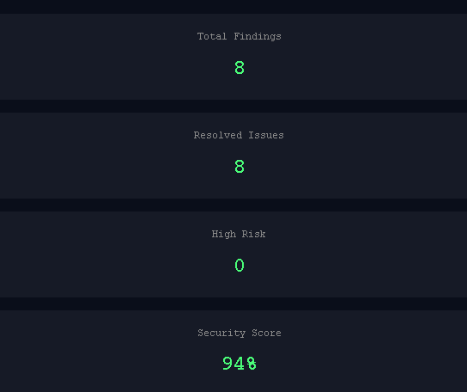
Fig 6.13: Penetration test summary dashboard showing total 8 findings with all 8 issues resolved, zero high-risk vulnerabilities remaining, and achieving a security score of 948.

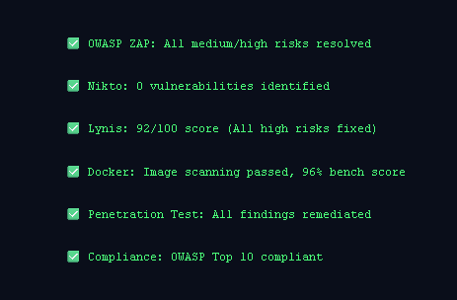
Fig 6.14: Final consolidated security assessment summary showing all tools passed OWASP ZAP with zero medium/high risks, Nikto with zero vulnerabilities, Lynis score 92/100, Docker image scanning passed with 96% bench score, penetration test findings fully remediated, and overall OWASP Top 10 compliance achieved.

